Objective
The objective of this practical is to create different types of data visualizations using Python libraries. These visualizations help in understanding data patterns, distributions, and relationships.

🟢 Tools Used
- Jupyter Notebook / Google Colab
- Python
- Pandas
- Matplotlib
- Seaborn

🟢 Dataset Used
COVID-19 / Medical Dataset (CSV File)

🔹 STEP 1: Import Required Libraries
In this step, all necessary libraries for data analysis and visualization were imported to prepare the environment.
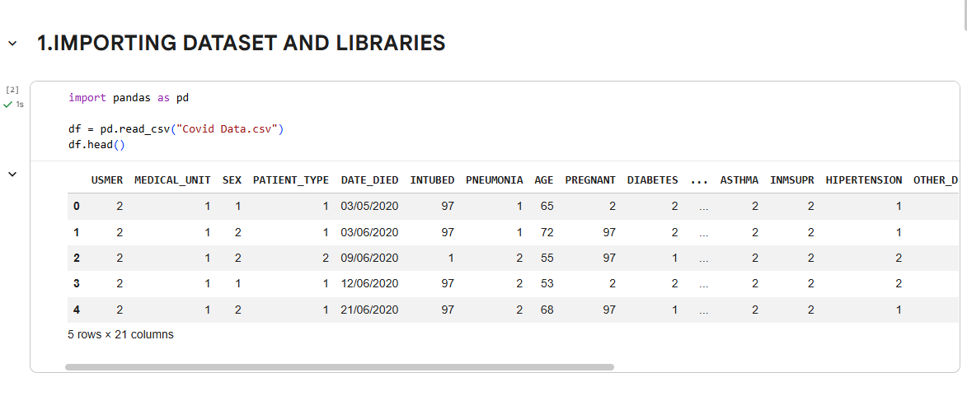

🔹 STEP 2: Load the Dataset
The dataset file was loaded into the notebook for further processing and visualization.

🔹 STEP 3: Display the Dataset
The first few rows of the dataset were displayed to understand its structure and contents.
🔹 STEP 4: Histogram (Age Distribution)
A histogram was created to analyze the distribution of age values in the dataset.
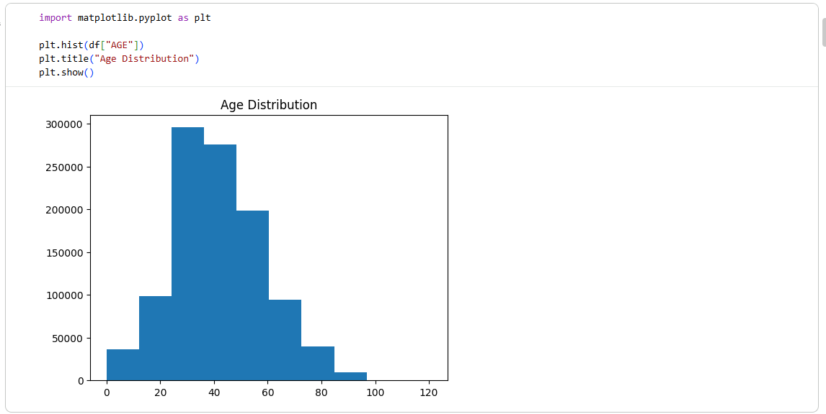

🔹 STEP 5: Bar Chart (Gender Distribution)
A bar chart was used to show the count of different categories in the gender column.
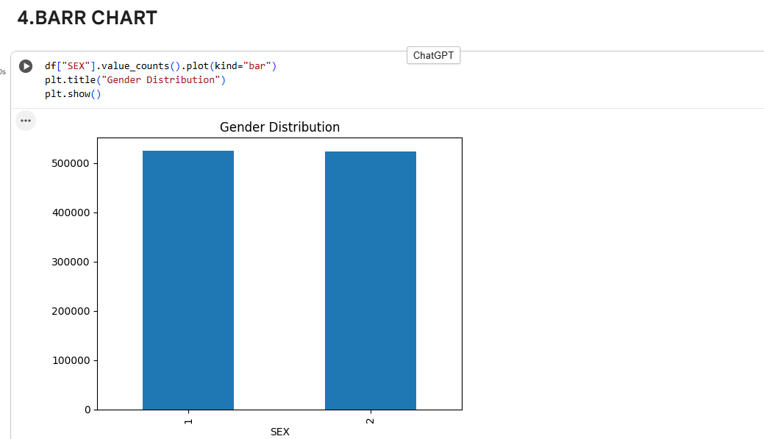

🔹 STEP 6: Scatter Plot (Relationship Analysis)
A scatter plot was created to analyze the relationship between age and another health-related variable.
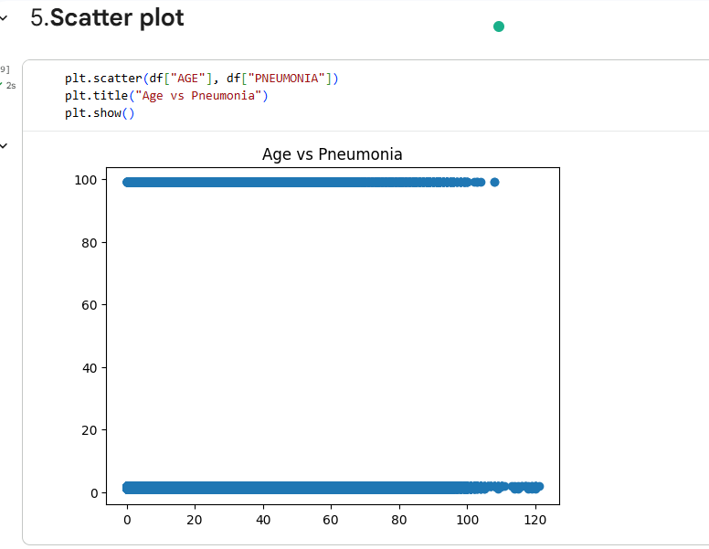

🔹 STEP 7: Box Plot (Statistical Distribution)
A box plot was used to visualize the spread and outliers of age data.
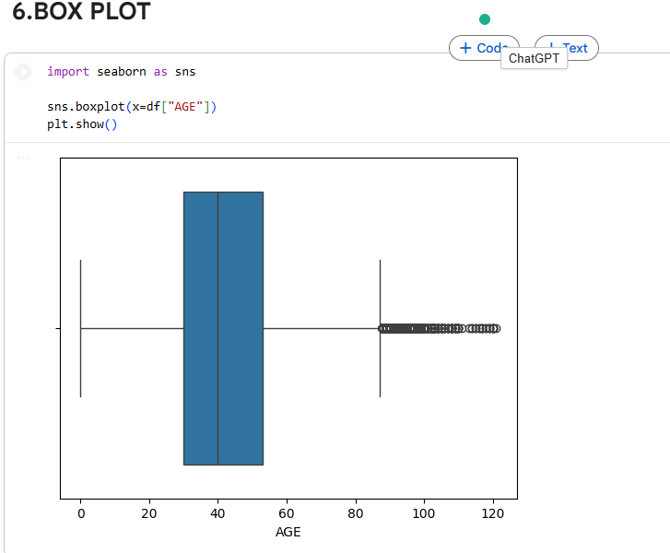

🔹 STEP 8: Violin Plot
A violin plot was created to show the distribution and density of the age data.
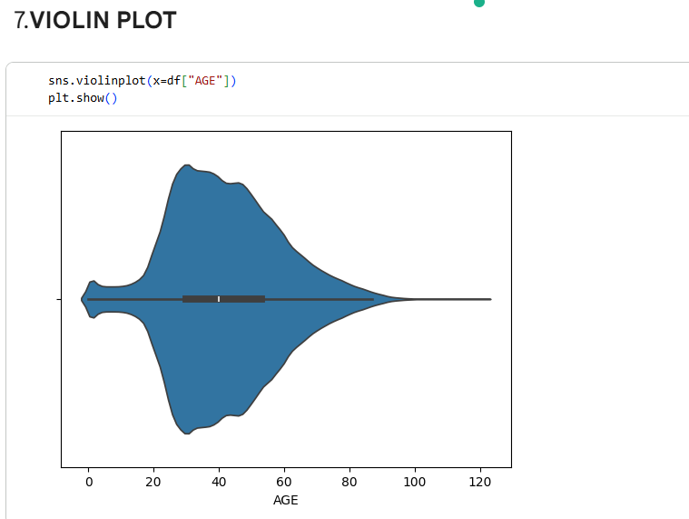

🔹 STEP 9: Heatmap (Correlation Matrix)
A heatmap was generated to visualize the correlation between numerical variables in the dataset.
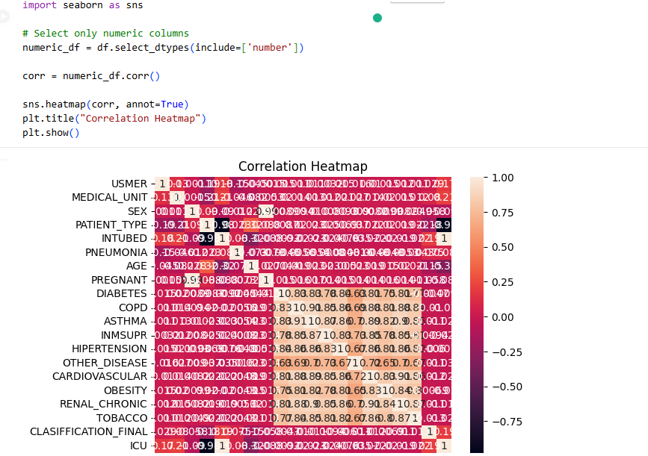

🔹 STEP 10: Customized Plot
A customized plot was created with titles and labels to improve visualization clarity.
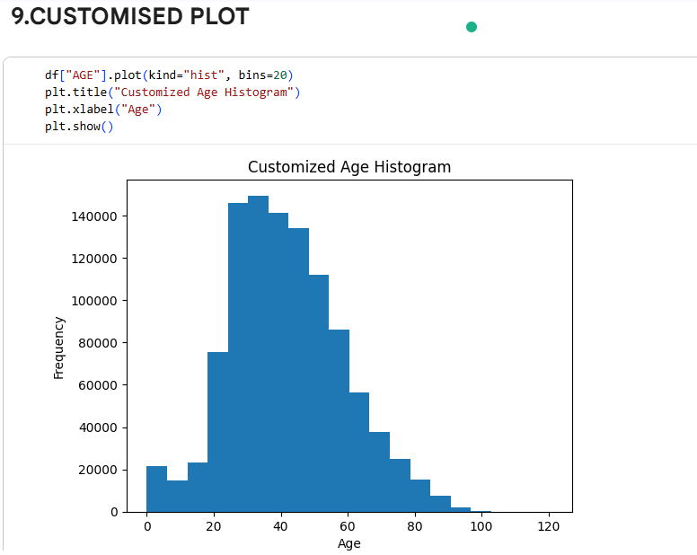

🔹 STEP 11: Subplots
Multiple plots were displayed in a single figure to compare different visualizations side by side.
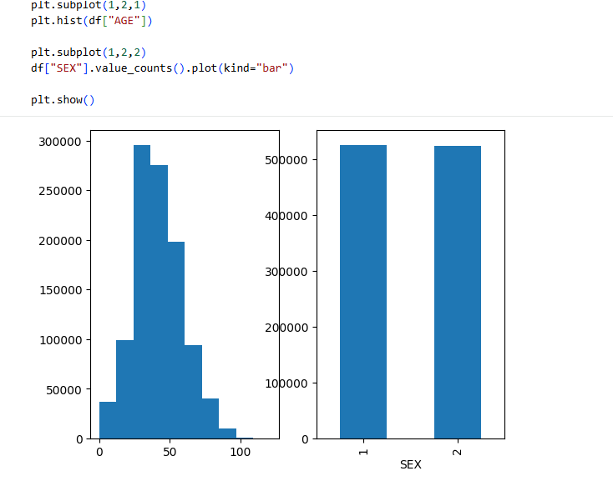

🔹 STEP 12: Pie Chart
A pie chart was used to show the percentage distribution of categorical data.
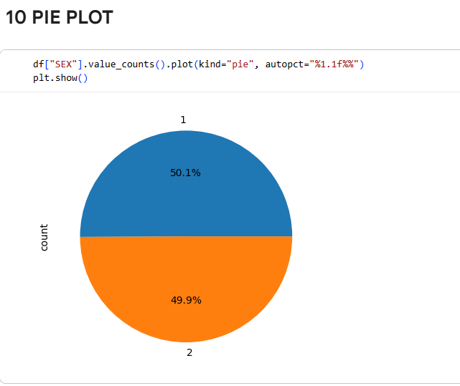

🔹 STEP 13: Line Plot
A simple line plot was created to represent a trend from a selected sample of data.
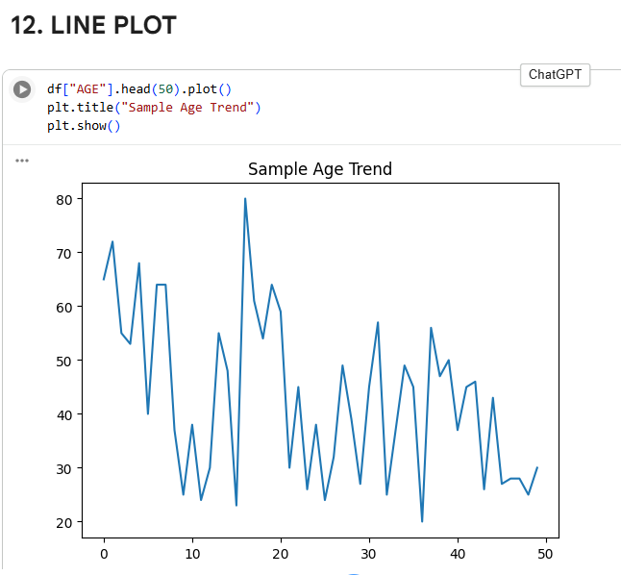

🟢 Conclusion
In this practical, multiple visualization techniques were applied to analyze the dataset. Graphical representations such as histograms, bar charts, scatter plots, and heatmaps made it easier to understand patterns and relationships in the data.

